# STORY BOARD

## Wire Frame-

 

 

 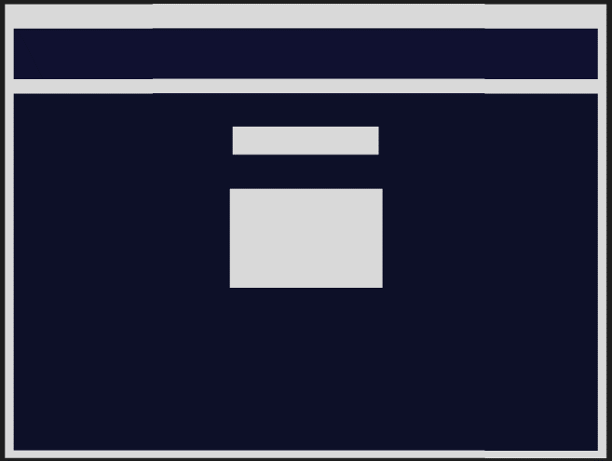

## Web-Pages:

Home/Index- The purpose of the page is to welcome the user to my portfolio.

Personality- This page’s purpose is to give insight into who I am as a person and to show who I use to influence and motivate me

Professional- This page is used to show where I see myself in the future, what my dream job requires of me, my professional goal and what I vow to do to reach it.

About Me- This page is used to give a bit about my backstory and to let the reader feel like they know me a little.

Personal Development- I use this page to share my thoughts on a few chapters of the book “Twelve Pillars” and share what I plan to use the information leant from the book to gain success for myself.

Story Board- This page’s purpose is to allow for the story board pdf to be downloaded.

## Theme:

The theme of my portfolio is “calm night”, I want the portfolio to give off a sense of calm to the user. The dark tones are used to make the viewing experience as easy as possible.

## Features:

* Static images
* Interactive image
* Video

**References**

Portfolio style-

<https://www.figma.com/community/file/1239154471346181079/about-me-personal-portfolio-website-template>

Video used for my hero-

<https://www.youtube.com/watch?v=9fLQoslYE-8>

Twelve Pillars-

<https://utechonline.utech.edu.jm/pluginfile.php/679851/mod_resource/content/4/Twelve%20Pillars.pdf>

Website used for assistance-

<https://www.w3schools.com/tags/tag_video.asp>

Wire Frame-

<https://www.figma.com>